**Zen class day 10 html tasks:**

1. Fix the bugs in below snippet

<html lang="en">

<head>

<title>Document

<body>

guvi

</title>

</head>

<div>

Lorem ipsum dolor sit amet consectetur adipisicing elit.

<div>

<div>

Guvi Geek Network

</div>

</body>

</html>

Solution:

<html lang="en">

  <head>

    <title>Document guvi</title>

  </head>

  <body>

    <div>

      Lorem ipsum dolor sit amet consectetur adipisicing elit.

      <div>

        <div>Guvi Geek Network</div>

      </div>

    </div>

  </body>

</html>

Output:

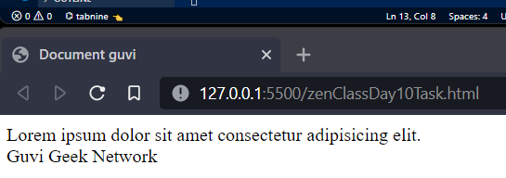

1. Try the below one

<html lang="en">

<head>

<title>Document

<body>

guvi

</head>

<div>

Lorem ipsum dolor sit amet consectetur adipisicing elit.

<div>

<div>

Guvi Geek Network

</div>

</body>

</html>

Solution:

<html lang="en">

  <head>

    <title>Document guvi</title>

  </head>

  <body>

    <div>

      Lorem ipsum dolor sit amet consectetur adipisicing elit.

      <div>

        <div>Guvi Geek Network</div>

      </div>

    </div>

  </body>

</html>

Output:

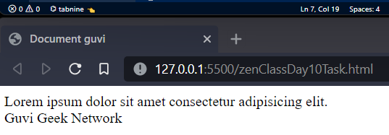

1. Design a contact us form with all fields as required

Solution:

<html>

  <head>

    <title>Contact us form</title>

  </head>

  <body>

    <h1>Contact Us</h1>

    <form action="https://www.google.com" method="get" target="_blank">

      <fieldset>

        <legend>please provide the details</legend>

        <br />

        <label for="name">Name* </label><br /><input

          type="text"

          name="name"

          id="name"

          placeholder="riyaz kaleem"

          required="required"

        /><br /><br />

        <label for="phno">Phone no </label><br /><input

          type="number"

          name="phno"

          id="phno"

        /><br /><br />

        <label for="emailid">Email Id* </label><br /><input

          type="email"

          name="email"

          id="email"

          placeholder="riyaz.marx@gmail.com"

          required="required"

        /><br /><br />

        <label for="comment">Comment your views: </label><br />

        <textarea name="comments" id="" cols="50" rows="10"></textarea>

        <br /><br />

        * fields are mandatory to be filled!!!<br /><br />

        <button>submit my data</button>

      </fieldset>

    </form>

  </body>

</html>

Output:  
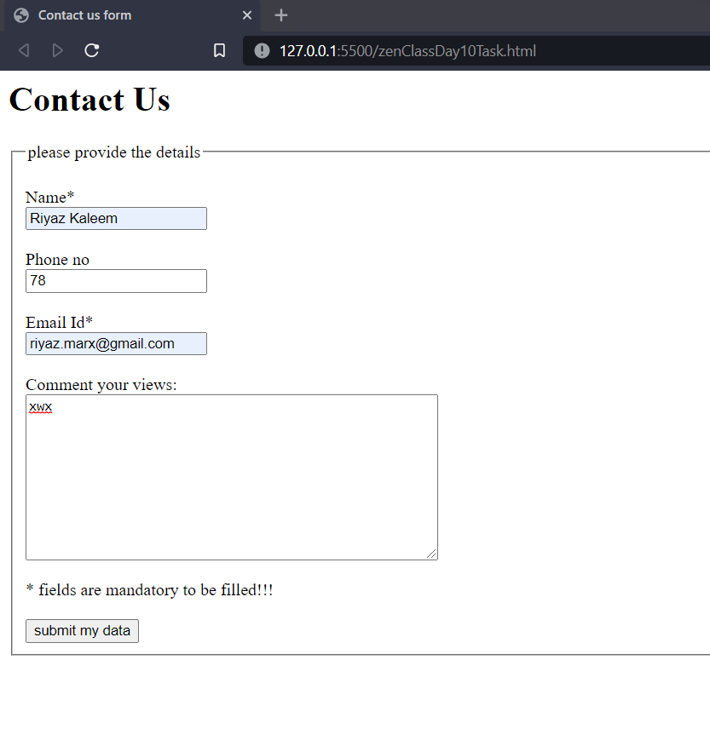

1. Use certain HTML elements to display the following in a HTML page.

* Programming Language
  + JavaScript
    1. Angular
    2. React
    3. Vue.js
  + Python
    1. Django Framework
    2. Flask Framework
  + Java
    1. Spring
    2. Maven
    3. Hibernate
* Database
  + MySQL
  + MongoDB
  + Cansandra

Solution:

<html>

    <head>

        <title>4th question - list</title>

    </head>

    <body>

    <p>

    <ul>

     <li>Programming Language</li>

     <ul>

         <li>Javascript</li>

         <ol>

             <li>Angular</li>

             <li>React</li>

             <li>Vue.js</li>

         </ol>

     </ul>

     <ul>

         <li>Python</li>

         <ol>

             <li>Django framework</li>

             <li>Flask framework</li>

         </ol>

     </ul>

     <ul>

         <li>Java</li>

         <ol>

             <li>Spring</li>

             <li>Maven</li>

             <li>Hibernate</li>

         </ol>

     </ul>

     <li>Database</li>

     <ul>

         <li>MySQL</li>

         <li>MongoDB</li>

         <li>Cansandra</li>

     </ul>

    </ul>

    </p>

</body>

</html>

Output:

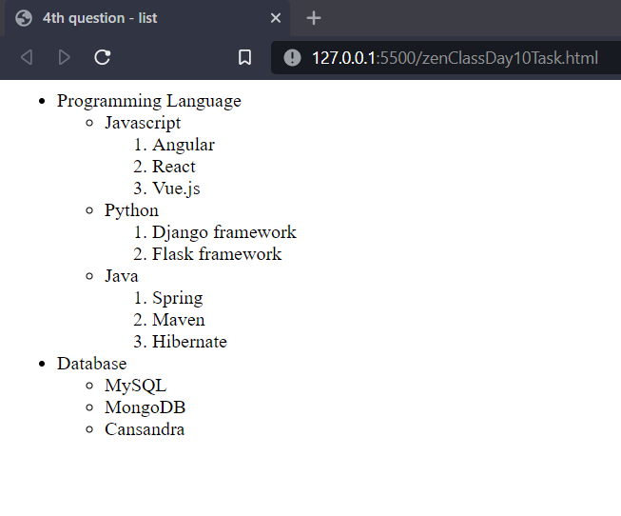

1. Create an element that helps you to open the [https://google.com](https://google.com/) in separate new tab.

Solution:

<html>

  <head> </head>

  <body>

      <form action="https://www.google.com" method="get" target="_blank">

      <p>practice exercise</p>

      <button>upload the data</button>

  </body>

</html>

Output:  
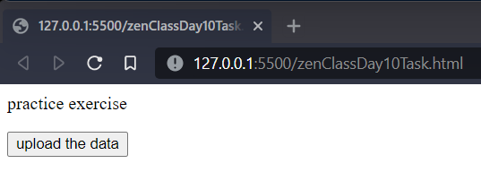

1. In the form, add two radio buttons with grouping them for employee type(Salaried and own business)

Solution:

<html>

  <head> </head>

  <body>

      <form action="https://www.google.com" method="get" target="_blank">

      <p>radio buttons grouping</p>

      <input type="radio" id="salary" name="employment" value="salary" />

      <label for="salary">Salaried </label><br />

      <input type="radio" id="business" name="employment" value="business" />

      <label for="business">own business </label><br />

      <br />

      <button>upload your data</button>

  </body>

</html>

Output:

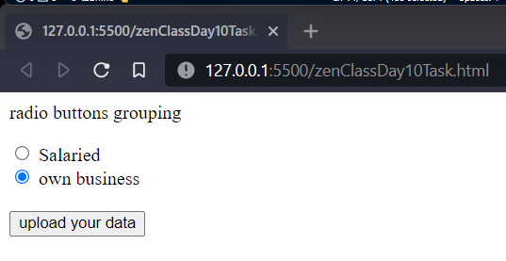

1. Design form shown in the link (<http://evc-cit.info/cit040/formguide/card_0.png>)

Solution:

<html>

  <head>

    <link rel="stylesheet" href="style.css" />

  </head>

  <body>

    <fieldset>

      <form action="https://www.google.com" method="get" target="_blank">

        <p id="redcol">Yes! I want to subscribe to <i>Mag-O-Zine</i></p>

        First Name

        <input type="text" name="firstname" maxlength="20" placeholder="Joe" />

        Last Name

        <input

          type="text"

          name="lastname"

          maxlength="20"

          placeholder="Schmegeggie"

        /><br /><br />

        Address

        <input

          type="text"

          name="address"

          maxlength="20"

          placeholder="1001 Washington Street"

        /><br /><br />

        City

        <input

          type="text"

          name="city"

          maxlength="20"

          placeholder="random city"

        />

        State

        <input type="text" name="state" maxlength="20" placeholder="CA" /> Zip

        <input

          type="text"

          name="zip"

          maxlength="20"

          placeholder="99999"

        /><br /><br />

        Subscribe for:

        <input type="checkbox" name="1year" value="1year" checked="checked" />1

        year ($19.95) <input type="checkbox" name="2years" value="2years" />2

        years ($35.00)<br /><br />

        Send me more information about: <br />

        <input

          type="checkbox"

          name="zine"

          value="computer"

          checked="checked"

        />Computer-Zine<br />

        <input type="checkbox" name="zine" value="fishing" />Fishing-Zine<br />

        <input

          type="checkbox"

          name="zine"

          value="cat"

          checked="checked"

        />Cat-O-Zine<br />

      </form>

    </fieldset>

  </body>

</html>

Output:  
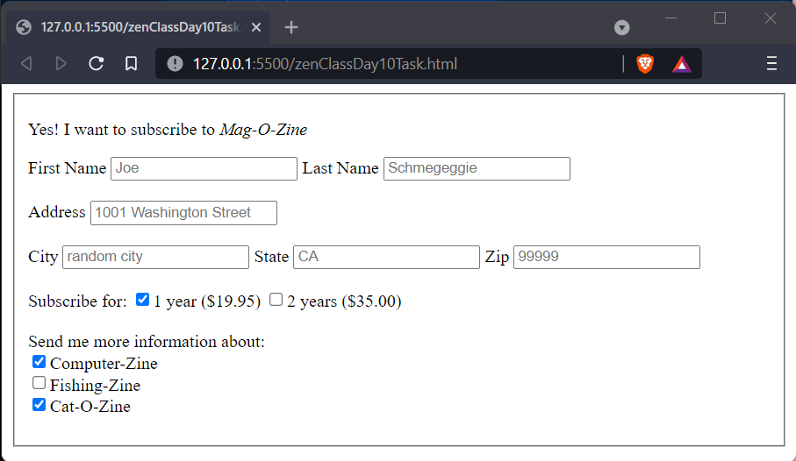

1. Use the table tag to design given image [Click here](https://www.bapugraphics.com/assets/img/port_upload_dir/table-4.jpg).

Solution:

<html>

  <head>

    <link rel="stylesheet" href="style.css" />

  </head>

  <body>

    <p align="center">Health Chart</p>

    <table border="2" cellspacing="3" cellpadding="3" align="center">

      <tr align="center">

        <th scope="col" rowspan="2">State of Health</th>

        <th colspan="2">Fasting Value</th>

        <th>After Eating</th>

      </tr>

      <tr align="center">

        <td scope="row">Minimum</td>

        <td>Maximum</td>

        <td>2 hours after eating</td>

      </tr>

      <tr align="center">

        <td scope="row">Healthy</td>

        <td>70</td>

        <td>100</td>

        <td>Less than 140</td>

      </tr>

      <tr align="center">

        <td scope="row">Pre-Diabetes</td>

        <td>101</td>

        <td>126</td>

        <td>140 to 200</td>

      </tr>

      <tr align="center">

        <td scope="row">Diabetes</td>

        <td>More than 126</td>

        <td>N/A</td>

        <td>More than 200</td>

      </tr>

    </table>

  </body>

</html>

Output:  
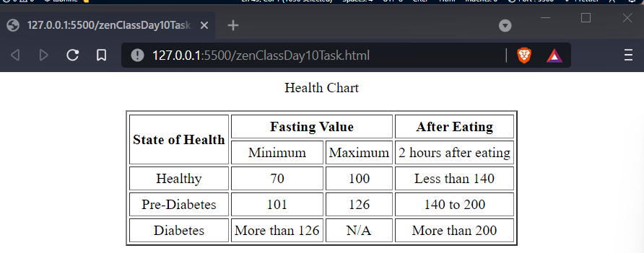

1. Write HTML input tags snippet to show default values for all Form elements.

Solution:

html>

  <head>

    <link rel="stylesheet" href="style.css" />

  </head>

  <body>

    <fieldset>

      <form action="https://www.google.com" method="get" target="_blank">

        <p id="redcol">Yes! I want to subscribe to <i>Mag-O-Zine</i></p>

        First Name

        <input type="text" name="firstname" maxlength="20" placeholder="Joe" />

        Last Name

        <input

          type="text"

          name="lastname"

          maxlength="20"

          placeholder="Schmegeggie"

        /><br /><br />

        Address

        <input

          type="text"

          name="address"

          maxlength="20"

          placeholder="1001 Washington Street"

        /><br /><br />

        City

        <input

          type="text"

          name="city"

          maxlength="20"

          placeholder="random city"

        />

        State

        <input type="text" name="state" maxlength="20" placeholder="CA" /> Zip

        <input

          type="text"

          name="zip"

          maxlength="20"

          placeholder="99999"

        /><br /><br />

        Subscribe for:

        <input type="checkbox" name="1year" value="1year" checked="checked" />1

        year ($19.95) <input type="checkbox" name="2years" value="2years" />2

        years ($35.00)<br /><br />

        Send me more information about: <br />

        <input

          type="checkbox"

          name="zine"

          value="computer"

          checked="checked"

        />Computer-Zine<br />

        <input type="checkbox" name="zine" value="fishing" />Fishing-Zine<br />

        <input

          type="checkbox"

          name="zine"

          value="cat"

          checked="checked"

        />Cat-O-Zine<br />

      </form>

    </fieldset>

  </body>

</html>

Output:  


In above code placeholder has been used for default values of elements

1. In your, HTML page add the below line and Highlight it without using any CSS.

* "HTML & CSS is awesome"

Solution:

<html>

  <head>

    <link rel="stylesheet" href="style.css" />

  </head>

  <body>

    <ul>

      <font color="blue">

        <li><p>"HTML & CSS is awesome"</p></li></font

      >

    </ul>

  </body>

</html>

Output:  
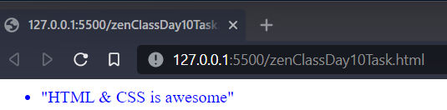

1. Create an HTML page, which should contain all types of input elements.

Solution:

<html>

  <head> </head>

  <body>

    <fieldset>

      <legend>

        <p id="redcol">form with all <i>input</i> elements</p>

      </legend>

      <form action="https://www.google.com" method="get" target="_blank">

        First Name

        <input type="text" name="firstname" maxlength="20" placeholder="Joe" />

        Last Name

        <input

          type="text"

          name="lastname"

          maxlength="20"

          placeholder="Schmegeggie"

        /><br /><br />

        Address

        <input

          type="text"

          name="address"

          maxlength="20"

          placeholder="1001 Washington Street"

        /><br /><br />

        City

        <input

          type="text"

          name="city"

          maxlength="20"

          placeholder="random city"

        />

        State

        <input type="text" name="state" maxlength="20" placeholder="CA" /> Zip

        <input

          type="text"

          name="zip"

          maxlength="20"

          placeholder="99999"

        /><br /><br />

        Subscribe for:

        <input type="checkbox" name="1year" value="1year" checked="checked" />1

        year ($19.95) <input type="checkbox" name="2years" value="2years" />2

        years ($35.00)<br /><br />

        Send me more information about: <br />

        <input

          type="checkbox"

          name="zine"

          value="computer"

          checked="checked"

        />Computer-Zine<br />

        <input type="checkbox" name="zine" value="fishing" />Fishing-Zine<br />

        <input

          type="checkbox"

          name="zine"

          value="cat"

          checked="checked"

        />Cat-O-Zine<br />

        <p>

          select between laptop and desktop<br />

          <input type="radio" name="item" value="laptop" /> laptop<br />

          <input type="radio" name="item" value="desktop" /> desktop<br />

        </p>

        <button>upload my data</button>

      </form>

    </fieldset>

  </body>

</html>

Output:  
